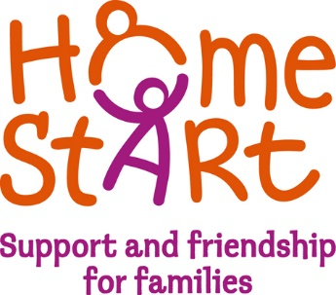
Home-Start Newcastle Borough

Volunteer Role Profile
Admin support volunteer

Office base: Cornerstone, High Street, Knutton, Newcastle-under-Lyme, ST5 6BX
Commitment: 2 – 3 hours a week
Supported by: Volunteer Co-ordinator/Office Coordinator

Purpose of the role;
Volunteers in this role will be supporting the volunteer and office coordinators with administration tasks in the Home-Start office.

Role responsibilities

- Assist the volunteer co-ordinator and administrator with the communication and inputting of the referrals into the volunteer service.
- Assist in updating our website and our social media with the promotion of our volunteer opportunities.
- Support the volunteer recruitment and communication process.
- To update family case notes in accordance with procedures and guidance.
- Assist the volunteer co-ordinator with the preparation and delivery of the volunteer training sessions.
- Putting together induction packs for new starters and information and guidance pack for families
- Completing any filing tasks as needed, such as archiving files, shredding, ensuring there is a good stock of forms and paperwork,

- Use your safeguarding level 1 knowledge to ensure the safety and protection of all children, young people, and adults.
- To ensure equality of opportunity, fairness, and diversity in all aspects of the scheme’s work.
- Attend regular supervision meetings (may be virtual) with the volunteer co-ordinator.
- To record your volunteering time, and complete an expense claim form each month

Safeguarding
- Provide emotional support to the family on any Child in Need plan or Child Protection Plan provided by /with Social Worker if appropriate.
- Use your safeguarding level 1 knowledge to ensure the safety and protection of all children, young people, and adults, and raise any concerns with the Volunteer Co-ordinator.

Admin Development & Training
- Attend and engage in regular supervision meetings (may be virtual) with the volunteer co-ordinator.
- Engage and complete identified training to benefit your role
- Identify own learning and personal development ambitions
- To keep up to date, case notes in accordance with procedures and guidance.
- To record your volunteering time, and complete an expense claim form each month

Training provided.

- All volunteers for this role will be required to complete the 4 week virtual telephone befriending training course. Volunteers may wish to complete the full home visiting course of preparation which allows volunteers to support with home visiting and telephone befriending if they wish to move on from supporting in the office.
- Safeguarding Level 1 must be attended.
- There are various free training opportunities that will be available to all volunteers. These may be virtual or face to face. These often include training around mental health awareness, early year’s development and domestic abuse awareness.
- All volunteers will have the opportunity to identify individual learning, development and training objectives with the Volunteer Coordinator during regular supervisions.

Skills and requirements

- Volunteers must be reliable and show commitment to supporting both the family support work team and Home-Start families
- Volunteers should be able to show a flexible approach where possible.
- Volunteers must show good time keeping.
- All volunteers must have good communication skills with Home-Start staff and families.
- Volunteers need to have a friendly disposition and be open and honest.
- Home-Start volunteers must be non-judgemental.
- Volunteers should be able to build positive relationships with families and Home-Start staff.
- Volunteers need to be able to travel to and from the office. This role will require volunteers to work in our admin office to fulfil the responsibilities started above

