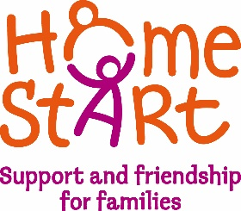

Home-Start Newcastle Borough
Cornerstone, High Street, Knutton, Newcastle under Lyme, Staffordshire. ST5 6BX

Job Application Monitoring Form

To ensure Home-Start Newcastle Borough’s implementation and development of its Equal Opportunities Policy, applicants are asked to complete the details below. This information, which will be used solely for monitoring purposes, will be treated as confidential. It will be separated on receipt of the application forms and before they are considered by the shortlisting panel.

The basic information on these forms will be transferred to a summary sheet for the purpose of retaining overall statistical information. These completed individual monitoring forms will then be destroyed.

The response to these questions will not affect the success or otherwise of a job application in any way.

Application for the vacancy
Where did you see the post advertised?
Sex (please tick) | Male | Female
Age
How would you describe your ethnic origin? (please tick) | Asian Indian  Pakistani  Bangladeshi  Other Asian background  Black Caribbean  African  Other Black  Chinese or other ethnic group  Chinese  Any other ethnic group  Mixed Any mixed background  White British  Irish  Other White background
Religion | No Religion  Christian  Buddhist  Hindu  Jewish  Muslim  Sikh  Other Religion
Are you registered as disabled at a job centre and a holder of a green card? (please tick) | Yes | No
Do you consider yourself to be disabled even though your disability is not registered? (please tick) | Yes | No
Sexual orientation | Heterosexual  Lesbian/gay men/bisexual

